Grade VII
Programme Management Office
Dublin South, Kildare and West Wicklow Community Healthcare
Job Specification & Terms and Conditions

Job Title and Grade | Grade VII,  Programme Management Office  Grade Code 0582
Campaign Reference | CHODSKWW/23/32
Closing Date | Monday 1st May 2023 @ 12 Noon
Proposed Interview Date (s) | Proposed interview dates will be indicated at a later stage. Please note you may be called forward for interview at short notice.
Taking up Appointment | A start date will be indicated at job offer stage.
Location of Post | There are currently two permanent posts available in the Programme Management Office (PMO) which require filling from this campaign.  The vacancies are located within Dublin South, Kildare and West Wicklow Community Healthcare, with a base at Oak House, Millennium Park, Naas, Co. Kildare.  A panel may be formed as a result of this campaign for Dublin South, Kildare and West Wicklow Community Healthcare from which current and future permanent and specified purpose vacancies of full or part-time duration may be filled.
Informal Enquiries | Name: Brian Kearney  Job title: Portfolio Lead  Email: brian.kearney@hse.ie
Details of Service | The PMO operates within the Chief Officers Office in Dublin South, Kildare and West Wicklow (DSKWW) Community Healthcare, HSE. It is established that change within a complex healthcare system is a constant. The aim of the PMO is to ensure a focus and provide support and guidance on the successful delivery of programmes/projects, in order to realise expected benefits across the entire portfolio of programmes/projects/work practices; that align with the organisation’s goals and strategic direction.  The main purpose of the PMO is to ensure investment and focus on the right projects, at the right time, to deliver organisational strategy and goals; deliver benefits to service users and value for money for the organisation; and increase project and change management capability to deliver service improvement and change.  The Sláintecare Report (2017) and Sláintecare Implementation Strategy (2018) provide a ten year roadmap for the reform of Health Services in Ireland. The reforms outlined in this programme aim to create a more sustainable, equitable, and cost effective system that delivers better, more effective and efficient services for the population of Ireland.  The national Sláintecare Implementation Strategy, which provides an outline of the actions to be undertaken on the 10 year journey, has been further distilled into what will become a yearly action plan. Similarly, DSKWW CHO has an Operational Plan that outlines priorities for delivery of change within the CHO.  PMOs within Community Healthcare Organisations (CHOs) and Hospital Groups (HGs) work to support their Chief Officers/CEOs, project owners/sponsors and local project teams in the delivery of Sláintecare reforms at local service level where they will be experienced by patients, families and service users.  Examples of key priorities for CHOs/ HGs in the early years of Sláintecare implementation include the establishment of Regional Health Areas, the implementation of Community Healthcare Networks and the implementation of Integration Fund projects.  The role of a Programme Management Office  An efficient and effective PMO is a fundamental requirement of any successful project  management approach. PMOs do not own projects, the function of the office is to embed project management tools, skills and best practices in projects and programmes. By embedding these aspects of project management, the PMO supports project owners and sponsors to appropriately plan for and implement Sláintecare reforms and agreed local service priorities in a managed and systematic way.  The PMO provides:  • Methodology: As a central point for approved project methodology, lessons learned and best practices, the PMO helps to set up systems that allow for the successful delivery of work that meets the project’s time, cost and quality requirements  • Governance: The office works to ensure that the governance structures, project teams at local and national level and other key stakeholders, as required, have the appropriate information at the appropriate times to make necessary decisions  • Integration: As an enabling service, the PMO connects projects and programmes across the CHO/ HGs and works with these teams to identify interdependencies and risks  • Delivery support: The PMO team assists projects to deliver on the agreed scope of work. This includes activities such as providing advice and practical support, as required, and developing required team competencies  • Oversight and Traceability: The PMO provides high level management of project documentation (e.g. risk registers, schedules, incident logs) and monitoring of programme and project performance. This work includes collating and reporting on programme and project status reports for the CHO governance structures and other relevant stakeholders.  Community Health aims to deliver an integrated healthcare system which is responsive to people’s needs at the lowest level of complexity for the local population. Focusing on service delivery and decision making at local level informed by national frameworks, allows the HSE to:  •provide better direct accountability;  •provide for increased decision making at local area level; and  •deliver services in the community through an integrated management structure.  By working together, the HSE plan seeks to deliver:  •A healthier start for children and reduced health inequities  •Reduced risk factors for chronic disease focusing on harmful alcohol use and rising obesity rates  •Increased community services and support to live independently in your own home or in the community  •Improved access to tests and specialist appointments, closer to home  •Reduced waiting times for diagnostic tests, outpatient appointments, in-patient and day case procedures  •Mental health support that aims to keep you well and responds quickly when you need it  •More person centred support for people with disabilities to live full, independent lives  The HSE Corporate Plan 2021-2024 includes 6 objectives and 5 enablers as outlined in the diagram below.  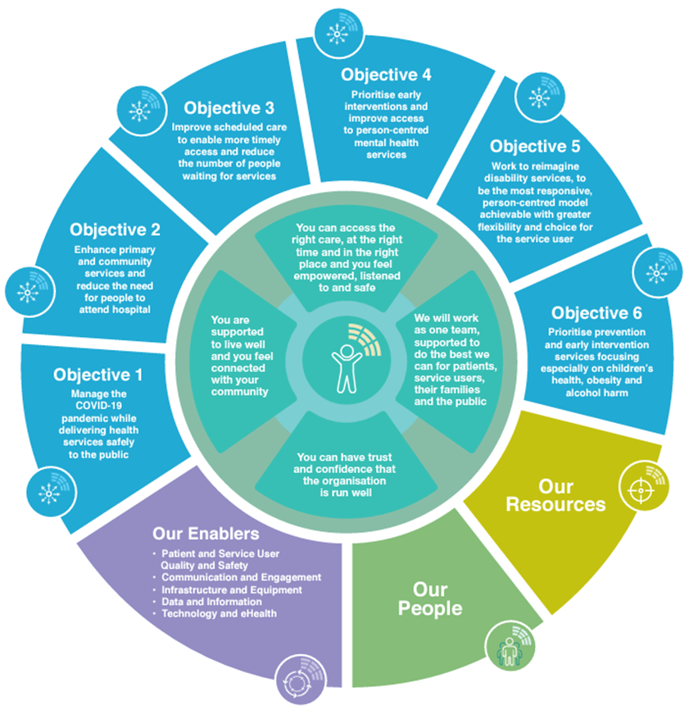
Reporting Relationship | The post holder will report to the Portfolio Lead or other nominated manager.
Purpose of the Post | The purpose of the Grade VII Project Manager role is to work as part of the PMO team to drive and actively support the delivery of various service reform, change programmes and local service priorities in the CHO. This role will also work to ensure that these programmes of work are implemented and delivered to cost, time and quality requirements through the application of the required standards, frameworks, tools and processes.
Principal Duties and Responsibilities | The position encompasses both managerial and administrative responsibilities which include the following:  Project Management  - Support the PMO in the management of the overall CHO portfolio. This includes the implementation of the Sláintecare Action Plan and local service priorities in the CHO, such as the roll out of InterRAI assessment and Enhanced Community Care Programme within DSKWW CHO.  - Manage the progress and completion of competing priorities, specific project tasks and activities including the supervision and development of staff in line with team requirements.  - Represent PMO on working groups and/or meetings: may include working with chair to communicate with members in a timely manner and develop agendas, taking and distributing minutes, following up on next steps between meetings.  - Assist with the managing of risks, dependencies and interdependencies with other programmes in the CHO portfolio to ensure a coordinated delivery of change across the organisation.  - Compile and maintain a standard suite of project reports to meet the requirements of key stakeholders.  - Proactively engage with multiple stakeholder groups.  - Maintain programme/project toolkits, templates and portfolio planning documents.  - Coordinate and schedule PMO meetings and activities.  Project Reporting:  - Work with PMO colleagues to establish standard process for collection and distribution of regular reporting data. Includes collating and analysing data and information and creating timely and accurate project reports in line with the agreed reporting format and guidelines.  - Support the implementation of a consistent and standardised process of project tracking and reporting across the portfolio using the PMO project management software.  - Provide support to PMO in the deployment of programme management processes, tools and templates.  Governance and Assurance  - Support PMO colleagues to ensure the successful implementation of projects. Includes ensuring that the appropriate level of project governance and controls are in place, maintained and adhered to.  - Support the Implementation of an end-to-end model of Programme Assurance for the PMO Sláintecare Portfolio.  Change Management  - Promote and participate in the implementation of change.  - Proactively identify inequities and inefficiencies in service administration and implement solutions to improve service delivery, in line with legislation and benchmarking against best practice structures.  - Embrace change and adapt local work practices accordingly by finding practical ways to make policies work, ensuring team knows how to action changes.  - Encourage and support staff through change process.  Service delivery and service improvement  - Demonstrate initiative in the resolution of complex issues and an ability to work independently.  - Identify opportunities for improvement and bring forward to PMO colleagues.  - Adopt a flexible and adaptable attitude to work and workload at all times.  - Monitor efficiency of service provided by team, identify and implement changes to the administration of the service where inefficiencies arise.  Administration  - Provide efficient administration and clerical support to PMO.  - Maintain and update filing systems and records as required using Excel, Word, Teams, PowerPoint and other relevant systems.  - Deal appropriately and efficiently with communications, queries, callers or visitors to the office.  - Assist with the preparation and management of documents required for meetings and presentations, as required.  - Organise, co-ordinate, attend and take minutes of meetings when required.  - Ensure deadlines are met and that service levels are maintained.  - Ensure accurate attention to detail in own work and work of team.  The above job specification is not intended to be a comprehensive list of all duties involved and consequently, the post holder may be required to perform other duties as appropriate to the post which may be assigned to him/her from time to time and to contribute to the development of the post while in office.
Eligibility Criteria  Qualifications and/ or experience | - Eligible applicants will be those who on the closing date for the competition:  Have no less than two years satisfactory experience in an administrative role  and  - Candidates must possess the requisite knowledge and ability, including a high standard of suitability, for the proper discharge of the office.  Health  A candidate for and any person holding the office must be fully competent and capable of undertaking the duties attached to the office and be in a state of health such as would indicate a reasonable prospect of ability to render regular and efficient service.  Character  Each candidate for and any person holding the office must be of good character.
Post Specific Requirements | - Experience of project managing complex change or quality improvement projects.  - Experience of operating or overseeing some or all of the relevant disciplines, including:  - Project Management  - Project Delivery  - Risk and Issue Management  - Resource Demand & Supply Planning  - Change Management  - Stakeholder Management  - Experience of implementing a complex change project with significant interdependencies and challenges.  - Experience of analysing data, generating and presenting reports in a professional manner, including writing, editing and proof-reading skills. To incorporate your high proficiency in using spreadsheets and/or databases to deliver solutions to services challenges and demonstrate impact of interventions.
Other requirements specific to the post | Travel  Access to appropriate transport to fulfil the requirements of the role.  Working hours  Flexibility in relation to working hours as relevant to the role.
Skills, competencies and/or knowledge | Professional Knowledge & Experience  Demonstrates:  - Knowledge of the Sláintecare Report (2017), Sláintecare Implementation Strategy (2018) and Towards a Model of Integrated Person-centred Care (2019) (the summary report of the public consultation on the process of Geographic Alignment of Community Healthcare Organisations (CHOs) and Hospital Groups)  - An understanding of Irish health services and HSE reform  - An understanding of the services provided by the HGs/CHOs  - Knowledge of the issues, developments and current thinking on best practice in relation to project management  - An understanding of the challenges of leading a complex change project with significant technology, process, clinical change, interdependencies and HR challenges  - Strong ability to analyse data, generate and present reports in a professional manner, including writing, editing and proof-reading skills.  Building and Maintaining Relationships including Teamwork & Leadership Skills  Demonstrates:  - The ability to build and maintain relationships with colleagues and other stakeholders and to achieve results through collaborative working  - The ability to work both independently and collaboratively within a dynamic team and multi stakeholder environment  - The ability to lead the team by example, coaching and supporting individuals as required.  - The ability to support, supervise, develop and empower staff in changing work practises in a challenging environment within existing resources.  Communications & Interpersonal Skills  Demonstrates:  - Excellent communication and interpersonal skills with an ability to engage effectively with a wide range of stakeholders.  - Effective verbal communication skills, delivering complex information clearly, concisely and confidently  - Excellent written communication skills including strong report writing and presentation skills  - Excellent communication and interpersonal skills in order to deal effectively with a wide range of stakeholders.  Planning & Organising and Delivery of Results  Demonstrates:  - The ability to successfully manage a range of different projects and work activities concurrently, utilising computer technology effectively and assigning work to others as appropriate to meet strict deadlines  - The ability to proactively identify areas for improvement and to develop practical solutions for their implementation  - The ability to embrace change and adapt local work practices accordingly by finding practical ways to make policies work, ensuring the team knows how to action changes  - The ability to use resources effectively, challenging processes to improve efficiencies where appropriate  - Evidence of effective project planning and organisational skills including an awareness of resource management and the importance of value for money.  Evaluating Information, Problem Solving & Decision Making  Demonstrates:  - Excellent analytical, problem solving and decision making skills  - The ability to quickly grasp and understand complex issues and the impact on service delivery  - The ability to confidently explain the rationale behind decision when faced with opposition  - Ability to make sound decisions with a well-reasoned rationale and to stand by these  - Initiative in the resolution of complex issues  - Experience in effective problem solving utilising an inclusive approach which fosters learning and self-reliance amongst teams.  Commitment to a Quality Service  Demonstrates:  - Evidence of incorporating the needs of the service user into service delivery  - Evidence of practicing and promoting a strong focus on delivering high quality customer service for internal and external customers  - Commitment to developing own knowledge and expertise  - Evidence of setting high standards of performance for self and others, ensuring accurate attention to detail and consistent adherence to procedures and current standards within area of responsibility
Campaign Specific Selection Process  Ranking/Shortlisting / Interview | A ranking and or shortlisting exercise may be carried out on the basis of information supplied in your application form. The criteria for ranking and or shortlisting are based on the requirements of the post as outlined in the eligibility criteria and skills, competencies and/or knowledge section of this job specification. Therefore it is very important that you think about your experience in light of those requirements.  Failure to include information regarding these requirements may result in you not being called forward to the next stage of the selection process.  Those successful at the ranking stage of this process (where applied) will be placed on an order of merit and will be called to interview in ‘bands’ depending on the service needs of the organisation.
Code of Practice | The Health Service Executive will run this campaign in compliance with the Code of Practice prepared by the Commission for Public Service Appointments (CPSA). The Code of Practice sets out how the core principles of probity, merit, equity and fairness might be applied on a principle basis. The Code also specifies the responsibilities placed on candidates, facilities for feedback to applicants on matters relating to their application when requested, and outlines procedures in relation to requests for a review of the recruitment and selection process and review in relation to allegations of a breach of the Code of Practice. Additional information on the HSE’s review process is available in the document posted with each vacancy entitled “Code of Practice, Information for Candidates”.  Codes of practice are published by the CPSA and are available on www.hse.ie/eng/staff/jobs in the document posted with each vacancy entitled “Code of Practice, Information for Candidates” or on www.cpsa.ie.
The reform programme outlined for the Health Services may impact on this role and as structures change the job specification may be reviewed.

This job specification is a guide to the general range of duties assigned to the post holder. It is intended to be neither definitive nor restrictive and is subject to periodic review with the employee concerned.

Grade VII
Programme Management Office
Terms and Conditions of Employment

Tenure | The initial vacancy is permanent and whole time.  The post is pensionable. A panel may be created from which permanent and specified purpose vacancies of full or part time duration may be filled. The tenure of these posts will be indicated at “expression of interest” stage.  Appointment as an employee of the Health Service Executive is governed by the Health Act 2004 and the Public Service Management (Recruitment and Appointments) Act 2004 and Public Service Management (Recruitment and Appointments) Amendment Act 2013.
Remuneration | The salary scale for the post is: (as at 01/03/2023)  €55,024 €56,367 €57,938 €59,514 €61,096 €62,508 €63,947 €65,346 €66,736 €69,128 €71,529 LSIs  New appointees to any grade start at the minimum point of the scale. Incremental credit will be applied for recognised relevant service in Ireland and abroad (Department of Health Circular 2/2011). Incremental credit is normally granted on appointment, in respect of previous experience in the Civil Service, local authorities, health service and other public service bodies and statutory agencies.
Working Week | The standard working week applying to the post is 35 hours.  HSE Circular 003-2009 “Matching Working Patterns to Service Needs (Extended Working Day / Week Arrangements); Framework for Implementation of Clause 30.4 of Towards 2016” applies. Under the terms of this circular, all new entrants and staff appointed to promotional posts from Dec 16th 2008 will be required to work agreed roster / on call arrangements as advised by their line manager. Contracted hours of work are liable to change between the hours of 8am-8pm over seven days to meet the requirements for extended day services in accordance with the terms of the Framework Agreement (Implementation of Clause 30.4 of Towards 2016).
Annual Leave | The annual leave associated with the post will be confirmed at contracting stage.
Superannuation | This is a pensionable position with the HSE. The successful candidate will upon appointment become a member of the appropriate pension scheme. Pension scheme membership will be notified within the contract of employment. Members of pre-existing pension schemes who transferred to the HSE on the 01st January 2005 pursuant to Section 60 of the Health Act 2004 are entitled to superannuation benefit terms under the HSE Scheme which are no less favourable to those which they were entitled to at 31st December 2004
Age | The Public Service Superannuation (Age of Retirement) Act, 2018* set 70 years as the compulsory retirement age for public servants.  * Public Servants not affected by this legislation:  Public servants joining the public service, or re-joining the public service with a 26 week break in service, between 1 April 2004 and 31 December 2012 (new entrants) have no compulsory retirement age.  Public servants, joining the public service or re-joining the public service after a 26 week break, after 1 January 2013 are members of the Single Pension Scheme and have a compulsory retirement age of 70.
Probation | Every appointment of a person who is not already a permanent officer of the Health Service Executive or of a Local Authority shall be subject to a probationary period of 12 months as stipulated in the Department of Health Circular No.10/71.
Infection Control | Have a working knowledge of Health Information and Quality Authority (HIQA) Standards as they apply to the role for example, Standards for Healthcare, National Standards for the Prevention and Control of Healthcare Associated Infections, Hygiene Standards etc. and comply with associated HSE protocols for implementing and maintaining these standards as appropriate to the role.
Health & Safety | It is the responsibility of line managers to ensure that the management of safety, health and welfare is successfully integrated into all activities undertaken within their area of responsibility, so far as is reasonably practicable. Line managers are named and roles and responsibilities detailed in the relevant Site Specific Safety Statement (SSSS).  Key responsibilities include:  - Developing a SSSS for the department/service, as applicable, based on the identification of hazards and the assessment of risks, and reviewing/updating same on a regular basis (at least annually) and in the event of any significant change in the work activity or place of work.  - Ensuring that Occupational Safety and Health (OSH) is integrated into day-to-day business, providing Systems Of Work (SOW) that are planned, organised, performed, maintained and revised as appropriate, and ensuring that all safety related records are maintained and available for inspection.  - Consulting and communicating with staff and safety representatives on OSH matters.  - Ensuring a training needs assessment (TNA) is undertaken for employees, facilitating their attendance at statutory OSH training, and ensuring records are maintained for each employee.  - Ensuring that all incidents occurring within the relevant department/service are appropriately managed and investigated in accordance with HSE procedures.  - Seeking advice from health and safety professionals through the National Health and Safety Function Helpdesk as appropriate.  - Reviewing the health and safety performance of the ward/department/service and staff through, respectively, local audit and performance achievement meetings for example.  Note: Detailed roles and responsibilities of Line Managers are outlined in local SSSS.

A template SSSS and guidelines are available on the National Health and Safety Function/H&S web-pages
See link on health and safety web-pages to latest Incident Management Policy

